Bash_Challange

* Write a bash script to find the latency from the sample nginx log file.

Bash script should only only print the latency.

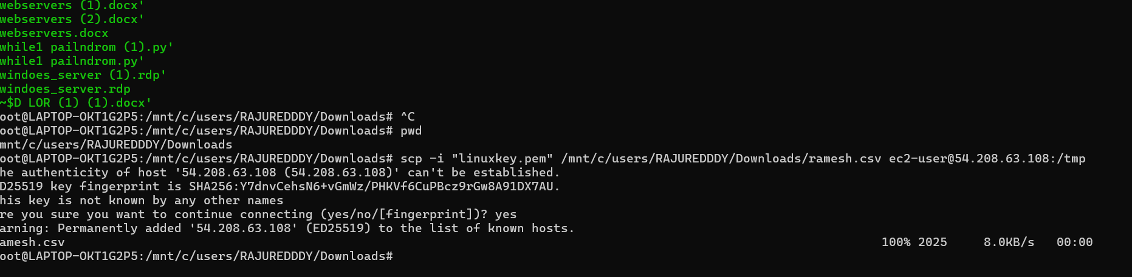

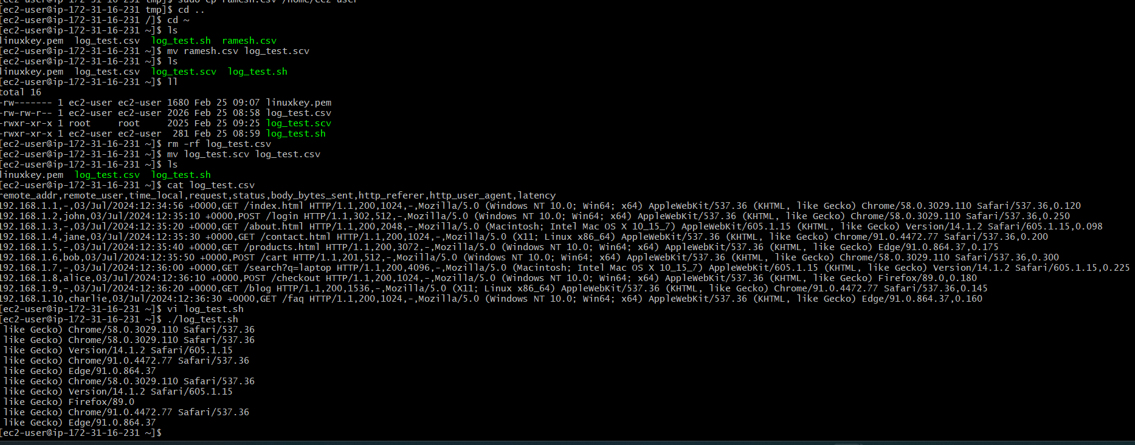

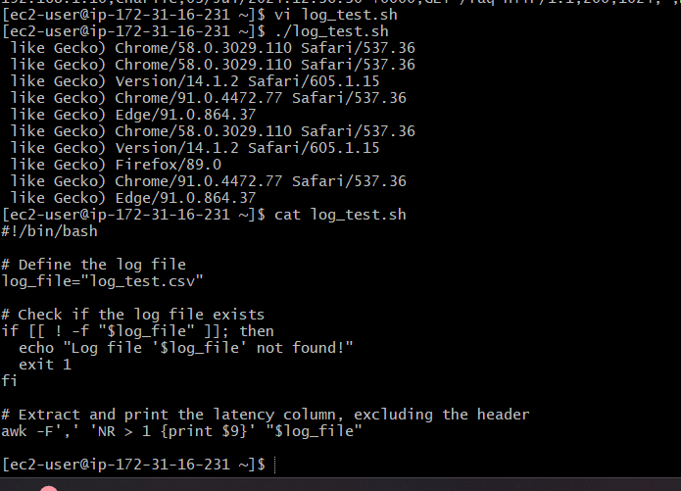

2. Bash Script to create repo in github.

